**Data Flow Diagram**

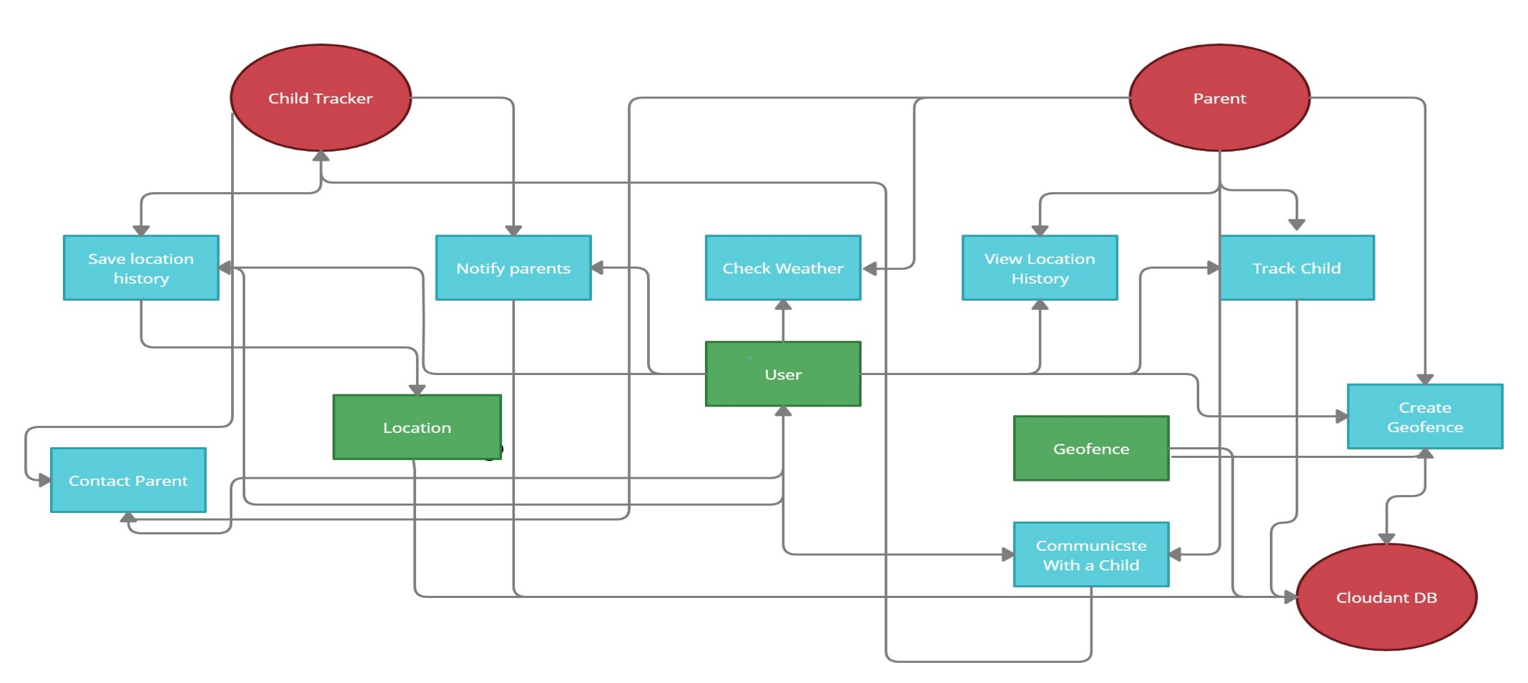Data Flow Diagram

|  |  |
| --- | --- |
| Date | 24 October 2022 |
| Team ID | PNT2022TMID27152 |
| Project Name | Project - IoT Based Safety Gadget for Child Safety Monitoring & Notification |
| Maximum Marks | 4 Marks |